28/04/2026
Egemen Çelik
2220357034

ELE432 Preliminary Work 3
Multi-Cycle RISC-V Processor

1) I spent total of 5 hours on this preliminary work. Note: All of the codes are in GitHub.

2)
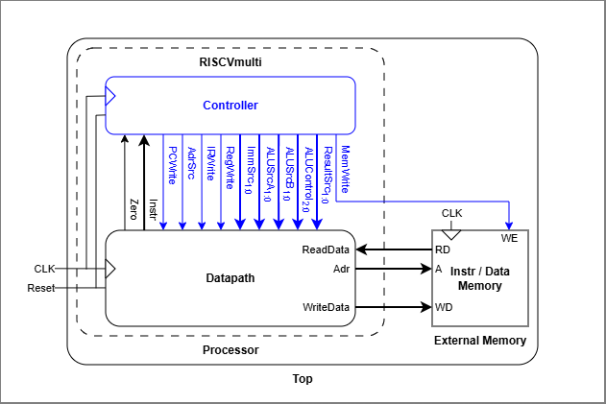
Figure 1

3) RTL Schematic showing the Top-Level Processor Module and the Processor:
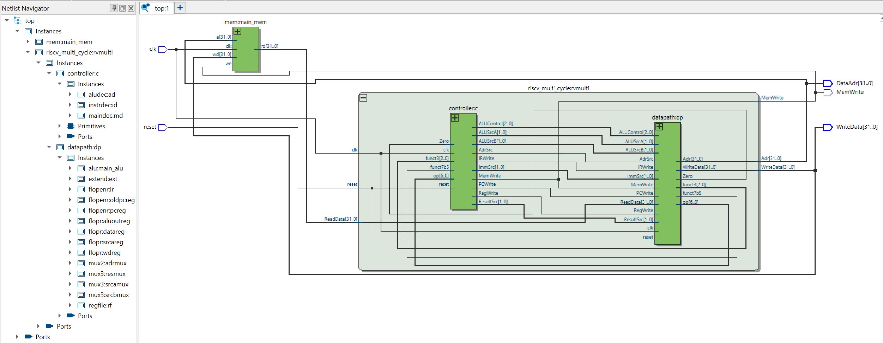
Figure 2
4)
Table 1: Expected Operation (after two cycles of reset)
Step | PC | Instr | State | Result (Hex) | Result Notes
3 | 00 | 00500113 | S0: Fetch | 04 | PC+4
4 | 04 | “ “ | S1: Decode | X | OldPC+Immediate
5 | 04 | “ “ | S8: ExecuteI | X | ALUResult = x0 (0) + 5 = 5
6 | 04 | “ “ | S7: ALUWB | 05 | Result = ALUResult
7 | 04 | “ “ | S0: Fetch | 08 | PC+4
8 | 08 | 00C00193 | S1: Decode | X | OldPC+Immediate
9 | 08 | “ “ | S8: ExecuteI | X | ALUResult = x0 (0) + 12 = 12
10 | 08 | “ “ | S7: ALUWB | 0C | Result = ALUResult
11 | 08 | “ “ | S0: Fetch | 0C | PC+4
12 | 0C | FF718393 | S1: Decode | X | OldPC+Immediate
13 | 0C | “ “ | S8: ExecuteI | X | ALUResult = x3 (12) + (-9) = 3
14 | 0C | “ “ | S7: ALUWB | 03 | Result = ALUResult
15 | 0C | “ “ | S0: Fetch | 10 | PC+4
…and so on until the progam goes into a loop at PC = 0x50.

5) My system passes the testbench.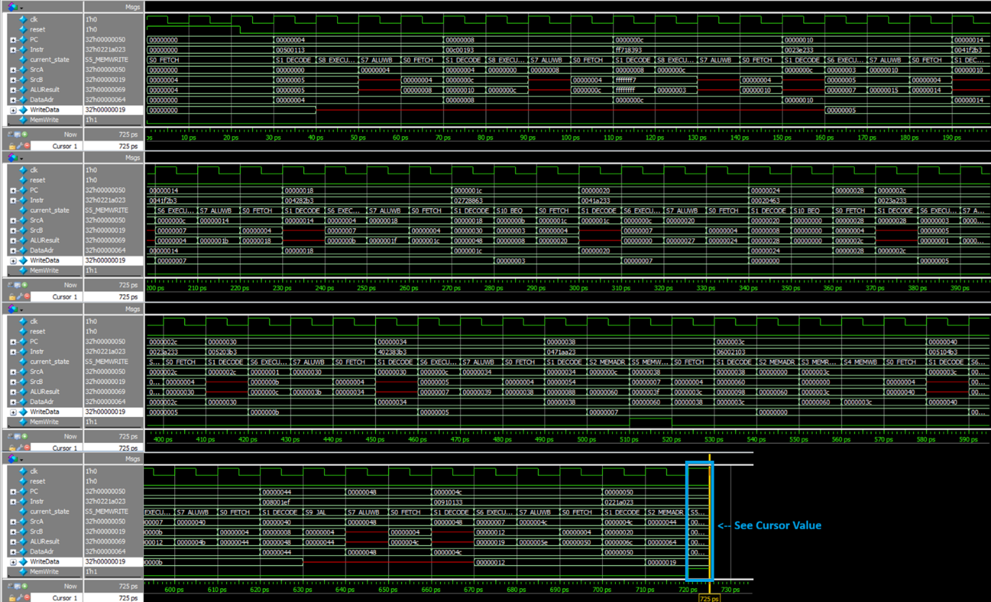
Figure 3

Questa Transcript Output:
run -all
# Simulation succeeded
# ** Note: $stop : C:/Projects/quartus/PRE3_Multi-Cycle_RISC-V_Processor/riscv_testbench.sv(30)
# Time: 725 ps Iteration: 1 Instance: /testbench
# Break in Module testbench at C:/Projects/quartus/PRE3_Multi-Cycle_RISC-V_Processor/riscv_testbench.sv line 30

6) GitHub Link: https://github.com/20egemen04/Multi-Cycle_RISC-V_Processor

